**Joystick to differential drive:**

**Algorithm:**

The input values for the microcontroller come from two potentiometers connected to A0 and A1 these control the throttle (Y-axis) and steering (X-axis). The input is in the form as represented below:

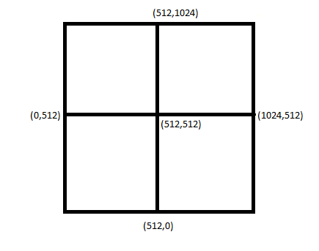

This input (varying from 0 to 1024) is scaled to an output (varying from -255 to +255). The output is represented below:

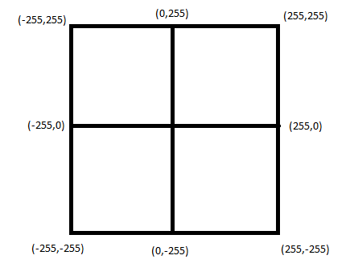

Now throttle and steering are mixed together

**leftMotorRaw = throttle + steering**

**rightMotorRaw = throttle - steering**

Respective scales are calculated

**LeftMotorScale = abs (leftMotorRaw/255)**

**RightMotorScale = abs (rightMotorRaw/255)**

From these the maximum between (RightMotorScale, LeftMotorScale, 1) is calculated

Now using this MaxScale the respective raw motor values can be properly scaled

**LeftMotorOutput = leftMotorRaw/MaxScale**

**RightMotorOutput = rightMotorRaw/MaxScale**

This is represented in the figure below:

